Abstract

[Draw your reader in with an engaging abstract. It is typically a short summary of the document.   
When you’re ready to add your content, just click here and start typing.]



Daniel in wells

Danielpratama18@gmail.com

Evaluate and Communicate Biz Req

# Assessment –

# Research & Questioning

|  |  |  |  |
| --- | --- | --- | --- |
| Name of Student | Daniel Pratama | ID | 18268 |

Contents

Assessment – 1

Research & Questioning 1

***Instructions:*** 1

***Business Scenario*** 1

***Task 1: Determine support areas*** 2

***Task 2: Identify stakeholders*** 3

***Task 3: Develop support procedures*** 4

***Task 4: Assign Support Personnel*** 6

***Task 5: Short Answer Questions*** 6

***Task 6: Multiple Choice Questions*** 7

Index 12

#### View My Web Support:

<https://danielpratama18.github.io/ECBR18268>

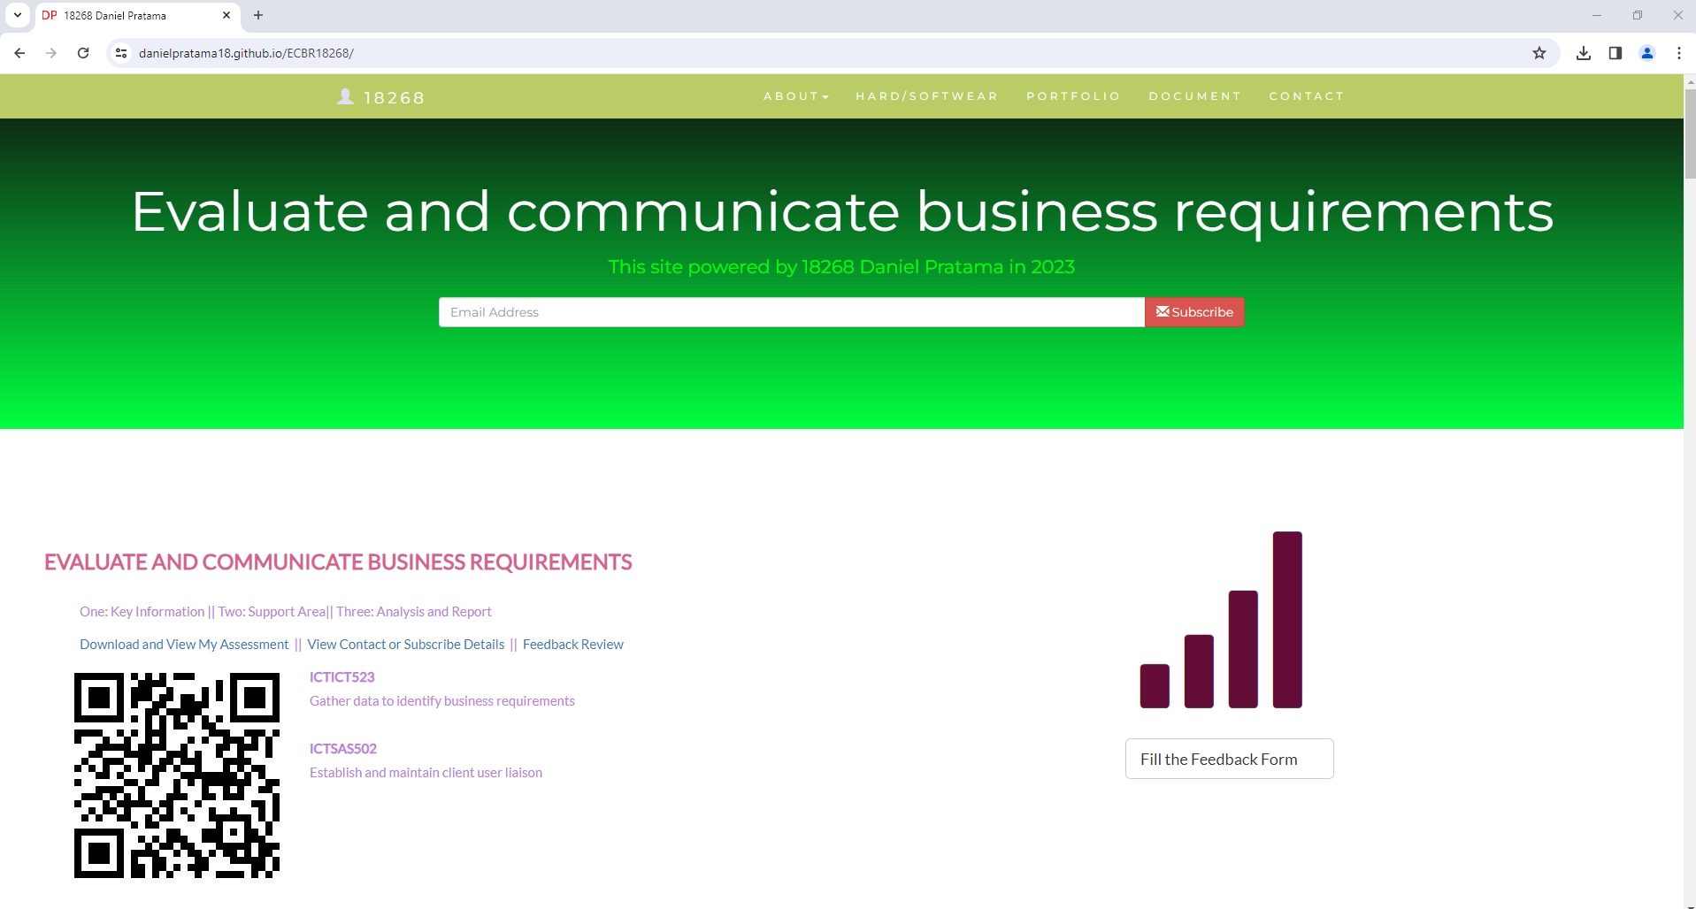

#### *Instructions:*

This assessment is to be completed individually. In this assessment you will be working through a number of written tasks based on case scenarios or research that relate directly to each element of competency for this cluster. Outlined below is information on how each of the tasks relates the element of competency covered.

Learn how to make Google Form: <https://www.youtube.com/watch?v=BtoOHhA3aPQ&t=4s>

Your tasks:

#### *Business Scenario*

D&K Books Pty Ltd is a bookstore owned by Mr. Dean Kerr. The business occupies two levels of an office building connected by escalators and lifts. D&K Books employs approximately six sales staff, one operation manager, two administrative officers, a bookkeeper and a marketing manager. They have an Ethernet network consisting of ten PCs (Intel I3 Desktop cloned), two switches, a router and three printers. They use the QuickBooks software to manage their entire business, including sales, inventory, ordering, accounts receivable, accounts payable, payroll and employee management. They also have two EFTPOS terminals one on each floor.

D&K Books has a Linux server that stores all of the data including the QuickBooks database. The server is backed up to tape regularly. They also have a website (hosted on an Australian ISP’s server, dynamic and static pages using asp.net) on which customers can browse the product catalogue and view current specials. They also lease a telephone system from Live Telecoms. The PABX (phone system) consists of a main switchboard and five remote phones with three incoming lines and a message-on-hold queue system.

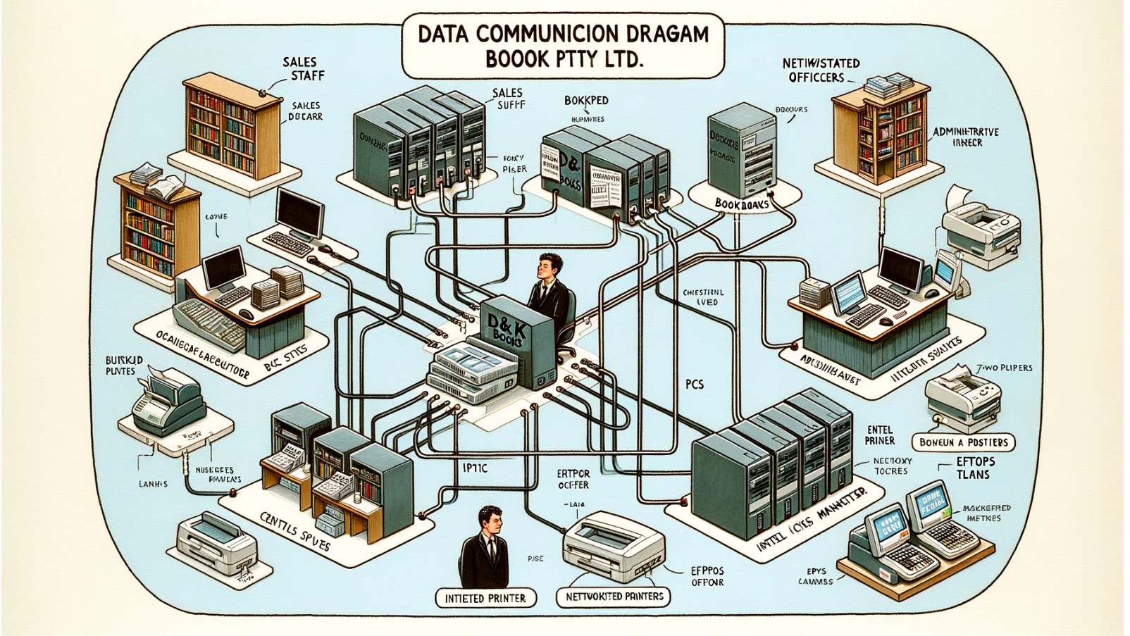

Good network system, you need setup at least:

|  |  |
| --- | --- |
| Hard ware | Software |
| Server X 1 | Window Server |
| Computer X 8 | Windows |
| Printer X 1 | SQL server |
| Telephone X 8 | Virus Protection |
| Modern X 2 | MS office |
| Network Cable | Eftpos machine More… |
| Network Router/Modem | Email Clients (e.g., Outlook, Gmail) |

#### *http://imapwebsolutions.com/wp-content/uploads/2014/07/linux-dedicated-server.pngTask 1: Determine support areas*

Identify information technology (HW and SW) and list the technology in use in D&K Books and consider the following:

* What sort of support does the technology require?
* Who is likely to provide this support?
* Does the support arrangement already exist?

Present your answer in a table such as the one below:

|  |  |  |  |  |
| --- | --- | --- | --- | --- |
| **Technology** | **Description** | **Support Required** | **Provider** | **Support Already exists? (Yes/No)** |
| QuickBooks Software | software that keeps track of all accounts, stock, GST, etc. | customisation, training, upgrades, bug fixes (patching), user support | [www.intuit.com.au](http://www.intuit.com.au)  online to find more | No |
| PC’s | Intel I3 Desktop cloned | upgrades, repairs, troubleshooting, maintenance, backup, customisation, network to link |  | No. Need find one person to do this job |
| **Server**  IconExperience » V-Collection » Server Icon | Linux Server with tape backup  May need upgrade to hard disk backup | User account management, security policy implementation, home folder management, permissions management, backup and restore, operating system patching, software installation |  | No |
| EFTPOS | Easy to use | No need | shop | Yes |
| Telephone system | Low cost | Phone company | Telstra | Yes |
| Website | Low cost | Yes | Godaddy | Yes |
| Network | wireless | No external | No | No |

Please review my website: <https://danielpratama18.github.io/ECBR18268/#businesscase>

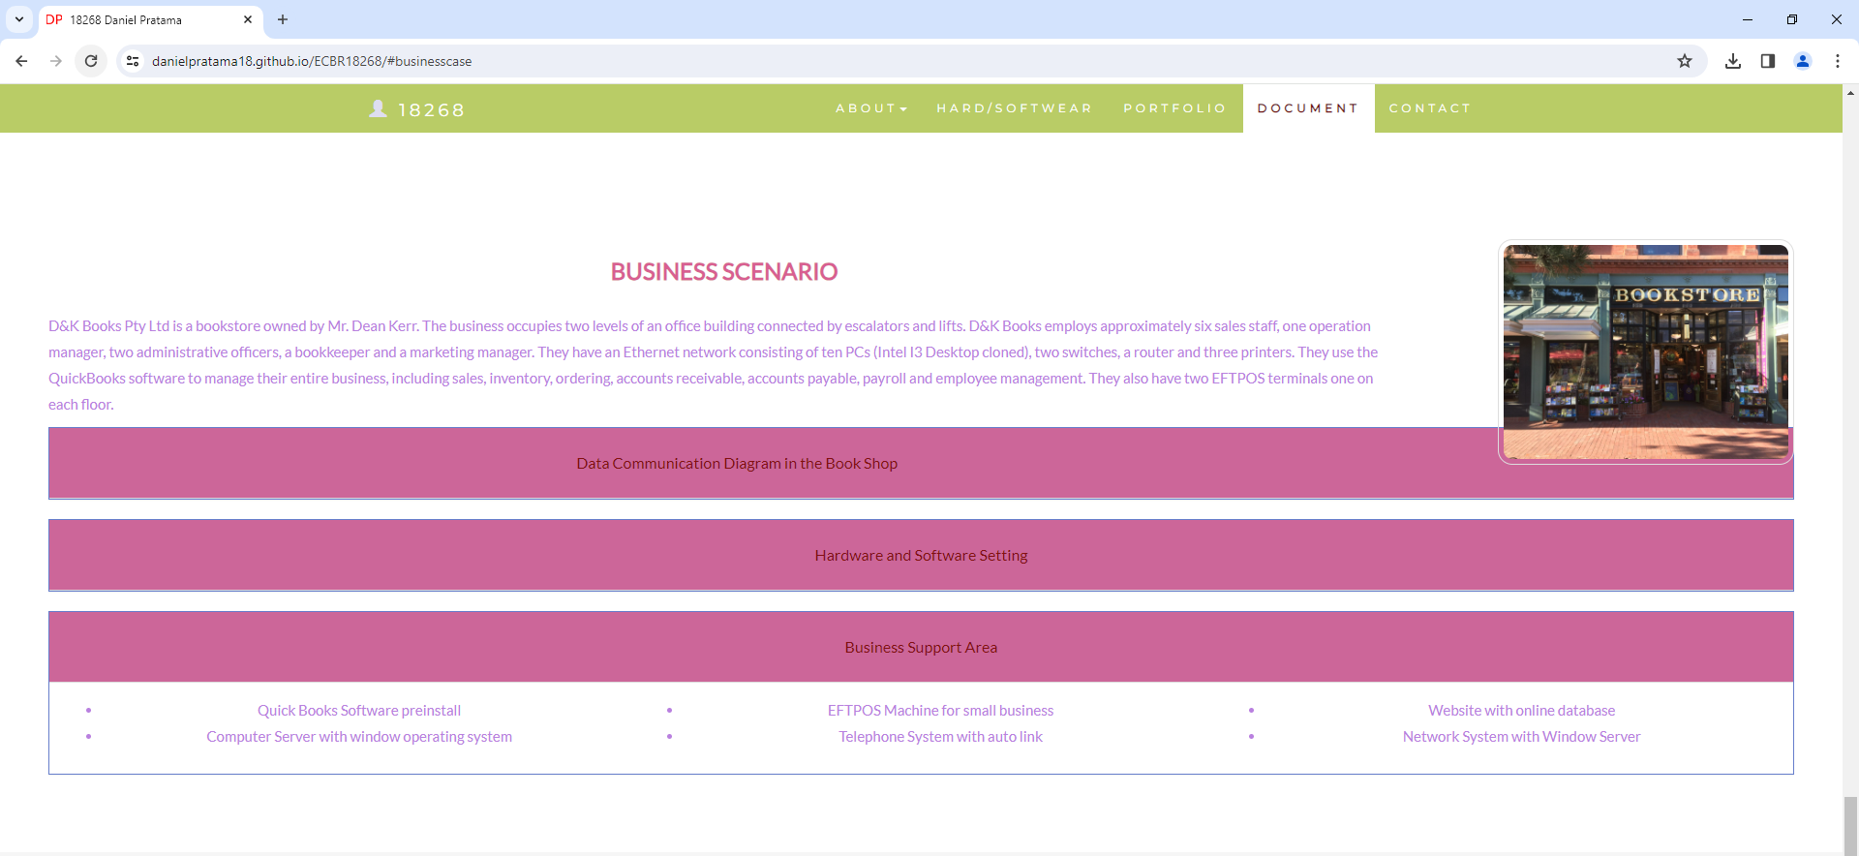

My web contact: <https://danielpratama18.github.io/ECBR18268/#contact>

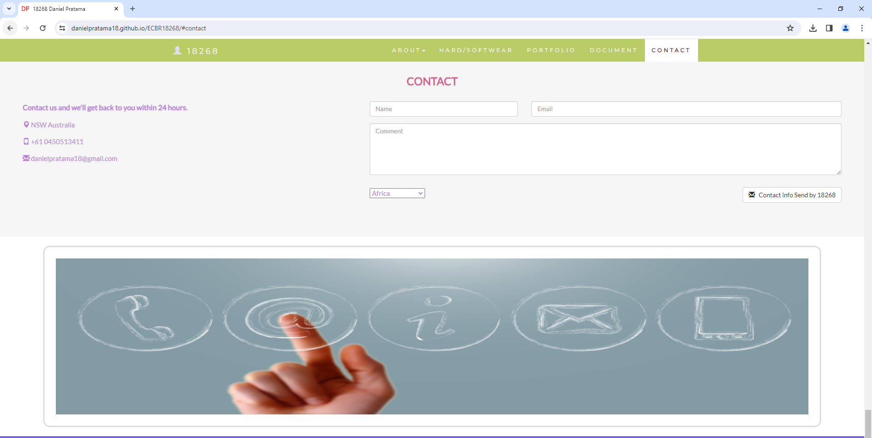

After your input, it will be recorded at:

You could be accessed by:

<https://docs.google.com/spreadsheets/d/1Z_Hz-0_p_bGEry6v4DE6fFvjQYbxCYk18FHVKoMc4Xw/edit#gid=440925468> 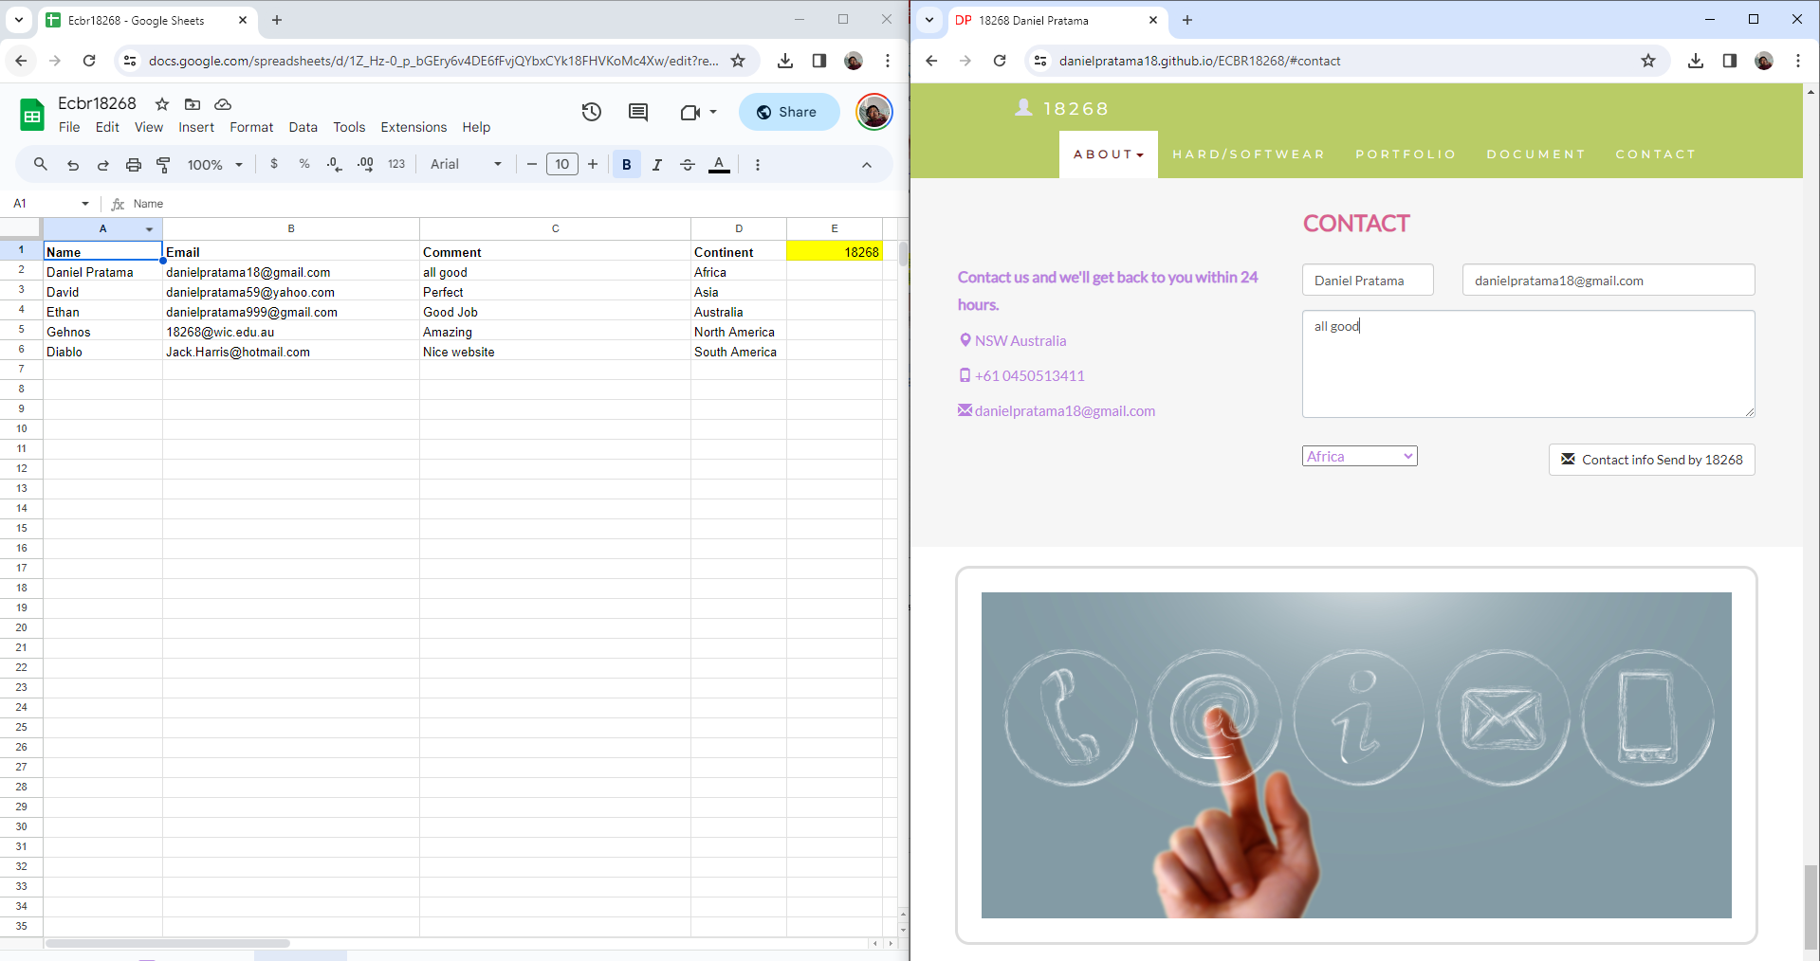

#### *Task 2: Identify stakeholders*

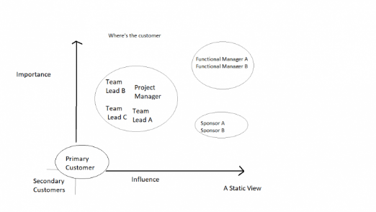 Identify stakeholders related in D&K Books system

All the staffs (the business owner, the relevant manager, the local workers and the remote workers) are stakeholders

Your comment:

Shows a stakeholder map with "Importance" on the vertical axis and "Influence" on the horizontal axis, categorizing 'Team Leads,' a 'Project Manager,' 'Functional Managers,' and 'Sponsors' by their levels of importance and influence. 'Primary Customer' is marked as important but with low influence, and 'Secondary Customers' as having lower importance and influence, with an overarching question about the customer's position in the context.

#### *Task 3: Develop support procedures*

1. Describe one positive and one negative experience you have had when seeking assistance from a telecommunication company, an ISP or a computer supplier. Your experience may be via telephone, email or even voice recognition.

|  |  |  |
| --- | --- | --- |
| Type | Positive | Negative |
| Telephone | Easy to get answer | Document provide |
| Email | Document, Picture, words or any media | Have to wait |
| Go to company | Face to face get answer | Cost time and money on trip |
| Zoom Meeting | Face to face get answer | Security Concerns, Limitations, and Technical Challenges. |

1. Using the experiences described above please answer the following questions.
   1. What support aspects were professional and/or unprofessional?

Professional aspects of support could include the ease of getting answers via Telephone and the possibility of using various media through Email or Zoom. Unprofessional aspects might relate to the negatives listed, such as the lack of document provision via Telephone or the waiting time associated with Email.

* 1. How long did the support process take?

The support process time is not indicated in the image. This would depend on the specific circumstances of each support incident.

* 1. Were the steps logical?

The steps seem logical in terms of escalating commitment and resources: starting with a phone call, followed by email correspondence, possibly a face-to-face visit, and a Zoom meeting if needed.

* 1. Did they solve your problem?

Whether the problem was solved is not addressed in the table. Problem resolution would depend on the specific context and effectiveness of the communication method used.

* 1. Was the call deflected to another area?

There is no mention of a call being deflected to another area in the table provided. Call deflection typically refers to directing a caller to a different department or support tier, and this information is not included in the table.

|  |  |  |
| --- | --- | --- |
| Items | professional | unprofessional |
| What support aspects | Friendly, Listening | Not what know your customer |
| How long | Very quick | Waiting and waiting |
| Steps logical | Yes | No |
| Solve | Good | Can not |
| Another area | If has, need solve | If has, do not care |

Using feedback form or Google survey form.

Here is the very simple survey demo:

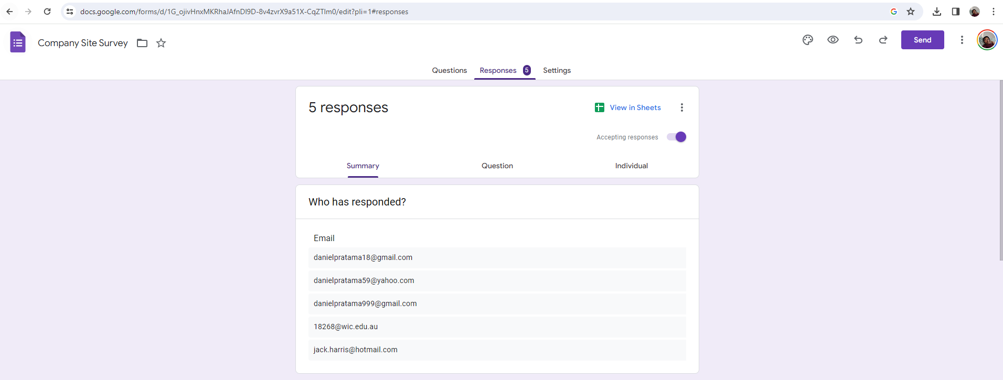

After I tested my friends, I could get nice response like:

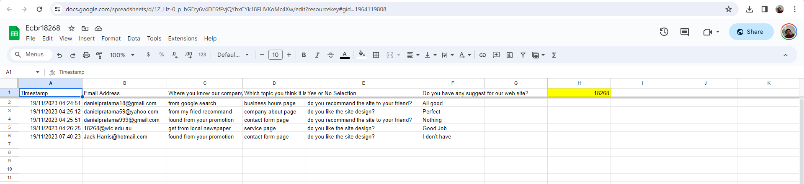

Or using link string:

<https://docs.google.com/spreadsheets/d/1Z_Hz-0_p_bGEry6v4DE6fFvjQYbxCYk18FHVKoMc4Xw/edit?resourcekey#gid=1964119808>

Please review my website:

<https://danielpratama18.github.io/ECBR18268/#taskthree>

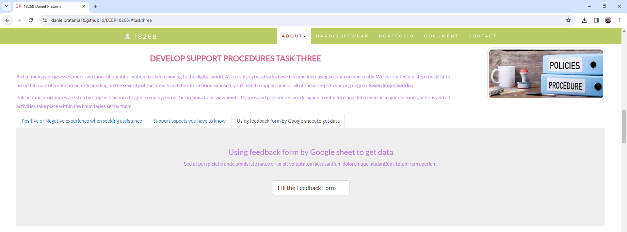

#### *Task 4: Assign Support Personnel*

Classify the following into soft skills and technical skills. Your answer should take the form of a table shown below.

|  |  |  |
| --- | --- | --- |
| **Skill** | **Soft skill** | **Technical skill** |
| A knowledge of Linux | X |  |
| The ability to work under pressure | X |  |
| The administration of Windows 2008 Server |  | X |
| The ability to formulate network and IT policies |  | x |
| The ability to write network documentation | x |  |
| The ability to give presentations | x |  |

#### *Task 5: Short Answer Questions*

1. 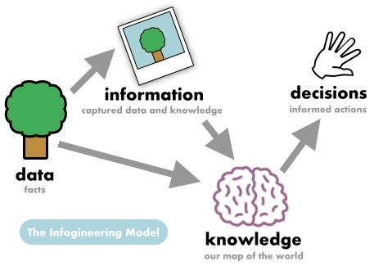Explain the relationship between data, information and knowledge.

* **Data** refers to raw, unprocessed facts and figures without any context. For example, data can be numbers, dates, and strings of text, observations, or even descriptions of things.
* **Information** is data that has been processed and structured in a meaningful way to become interpretable. Information is data with context and significance. For example, a list of dates and sales numbers becomes information when organized to show that sales peak every December.
* **Knowledge** is derived from extended experience or analysis of information. It represents an understanding, awareness, or familiarity gained through education or experience. When you understand the trend and reasons why sales peak in December, and you can predict or influence future events based on that pattern, that's knowledge.

1. What is quantitative data and how can you use it.

* Quantitative data is data that can be quantified and verified, and is amenable to statistical manipulation. Quantitative data defines whereas qualitative data describes. It can be used in various forms like numbers, quantities, or ranges.
* You can use quantitative data to measure and compare numerical values. For example, it can be used in statistical analysis to validate hypotheses, identify patterns, forecast scenarios, and make decisions based on empirical evidence.

1. What is qualitative data and how can you use it.

* Qualitative data is non-numerical data that can express the qualitative attributes of something, such as concepts, opinions, and experiences. It is descriptive in nature and can be observed rather than measured.
* You can use qualitative data to understand the underlying reasons, opinions, and motivations. It provides insights into the problem or helps to develop ideas or hypotheses for potential quantitative research. Qualitative data can be used in case studies, interviews, and narrative reports.

1. 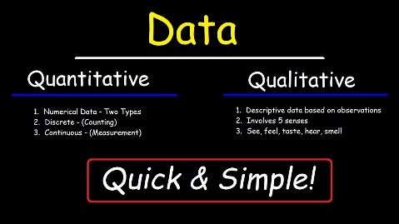Give an example of how quantitative and qualitative data can be used in conjunction with each other

In market research, a company may use quantitative data to find out how many people buy a product (e.g., 2,000 units sold per month). Concurrently, they might use qualitative data to explore why people prefer their product over competitors', using tools like focus groups or customer feedback (e.g., "it has a better taste" or "it's more user-friendly").

1. What sort of methods could you use to determine client requirements for a website design and key information sources?

* Interviews: Speaking directly with the client to understand their vision and needs.
* Questionnaires and Surveys: Gathering specific information from a larger group associated with the client’s business.
* User Stories: Creating brief explanations of features from the perspective of an end user.
* Market Research: Analysing competitors and industry standards to align the client's requirements with market expectations.
* Use Cases and Scenarios: Developing scenarios to understand how different users would interact with the website.
* Prototypes: Creating a basic version of the website to get feedback on the design and functionality.

1. Give some examples of client requirements for a website design

* Looks good
* 24 hours work
* Easy to update
* Upgrade is free
* Aesthetic Requirements: Specific colour schemes, branding elements, or themes that align with the company’s branding guidelines.
* Functional Requirements: Features such as search functionality, e-commerce capabilities, forms, and social media integration.
* Content Requirements: Types and volumes of content, such as text, images, videos, and blog integration.
* Usability Requirements: Easy navigation, mobile responsiveness, fast loading times, and accessibility standards.
* Security Requirements: Data protection measures, SSL certification, and secure payment gateways.
* SEO and Analytics Requirements: Search engine optimization for higher visibility and analytics tracking for user behaviour analysis.

#### *Task 6: Multiple Choice Questions*

1. 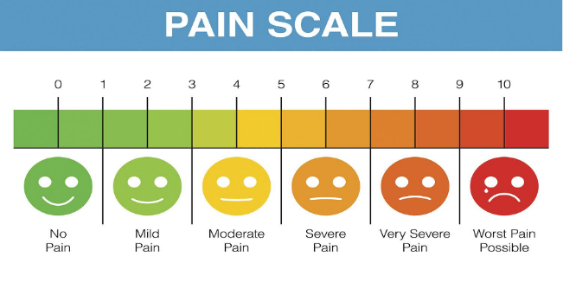Generally, how many points should a rating scale have?
   1. Five
   2. Four
   3. Ten
   4. Somewhere from 4 to 11 points Reason

Web refer: <https://lumoa.me/blog/rating-scale>

A rating scale is a closed-end survey question that is used to evaluate how survey responders feel about a particular product or statement.

Comment: I like 10 points. It is easy and clear to get the best feedback way.

1. What is the problem(s) with this set of response categories to the question “What is your current age?”

* 1-5
* 5-10
* 10-20
* 20-30
* 30-40
  1. The categories are not mutually exclusive
  2. The categories are not exhaustive
  3. Both a and b are problems
  4. There is no problem with the above set of response categories

Reason

The end point of one category is the starting point of another, leading to ambiguity for individuals whose age falls on these boundary numbers.

1. You should mix methods in a way that provides complementary strengths and no overlapping weaknesses. This is known as the fundamental principle of mixed research.
   1. True
   2. False

Reason

Combining various research procedures in a way that maximizes their strengths and minimizes their drawbacks is, in fact, the core idea of mixed-methods research. Researchers can obtain a deeper comprehension of the research problem by doing this. While quantitative methods can offer structure and generalizability, qualitative methods can offer depth and context. The idea is to make sure that the advantages of one approach are more than the disadvantages of another, with no flaws overlapping (for example, the subjectivity of qualitative research or the potential absence of context in quantitative data). The results of this multi method approach to study can be more trustworthy and solid.

1. According to the text, questionnaires can address events and characteristics taking place when?
   1. In the past (retrospective questions)
   2. In the present (current time questions)
   3. In the future (prospective questions)
   4. All of the above

Reason

Questionnaires are versatile tools in research and can be designed to address events and characteristics across different time frames. By including questions about the past, present, and future, researchers can gather comprehensive data relevant to their study's objectives.

1. Which of the following are principles of questionnaire construction?
   1. Consider using multiple methods when measuring abstract constructs
   2. Use multiple items to measure abstract constructs
   3. Avoid double-barrelled questions
   4. All of the above
   5. Only b and c

Reason

These principles are designed to improve the reliability and validity of the questionnaire data. By following these principles, researchers can create more effective questionnaires that provide clear, concise, and interpretable data.

1. Which of these is not a method of data collection?
   1. Questionnaires
   2. Interviews
   3. Experiments
   4. Observations

Reason

A questionnaire, an interview, or an observation is a means of gathering data; an experiment is not. Experiments are a type of research methodology where variables are controlled and manipulated in order to examine cause-and-effect relationships or test theories. Experiments entail gathering data, but their main goal is to evaluate a certain hypothesis or research issue through well planned trials or tests. On the other hand, methods including as surveys, interviews, and observations are more straightforward ways to collect data from people or circumstances without having to change variables in a controlled experiment.

1. Secondary/existing data may include which of the following?
   1. Official documents
   2. Personal documents
   3. Archived research data
   4. All of the above

Reason

The use of such data is common in various research fields, offering the advantage of being readily available and often providing a historical or comprehensive perspective on a subject. However, researchers must also consider the relevance, accuracy, and potential biases in these sources when utilizing them for their studies.

1. An item that directs participants to different follow-up questions depending on their response is called a ____________.
   1. Response set
   2. Probe
   3. Semantic differential
   4. Contingency question

Reason

Given description, "Contingency Question" (d) is the correct term for a question that leads to different follow-up questions based on the respondent's answer.

1. Which of the following terms best describes data that were originally collected at an earlier time by a different person for a different purpose?
   1. Primary data
   2. Secondary data
   3. Experimental data
   4. Field notes

Reason

**Secondary Data** (b): This refers to data that were collected by someone else for a different purpose but are being utilized by a researcher for a new study. Secondary data can come from various sources like government reports, research articles, historical records, and data sets from previous studies. The main characteristic of secondary data is that they were not collected by the researcher conducting the current analysis or study.

1. Researchers use both open-ended and closed-ended questions to collect data. Which of the following statements is true?
   1. Open-ended questions directly provide quantitative data based on the researcher’s predetermined response categories
   2. Closed-ended questions provide quantitative data in the participant’s own words
   3. Open-ended questions provide qualitative data in the participant’s own words
   4. Closed-ended questions directly provide qualitative data in the participants’ own words

Reason

Therefore, option (c) is correct because open-ended questions are designed to gather qualitative data in the participant's own words, allowing for a deeper exploration of their perspectives and experiences.

1. Open-ended questions provide primarily ______ data.
   1. Confirmatory data
   2. Qualitative data
   3. Predictive data
   4. None of the above

Reason

Therefore, the correct answer is b) Qualitative data, as open-ended questions are designed to elicit detailed, descriptive responses that are best categorized as qualitative.

1. Which of the following is true concerning observation?
   1. It takes less time than self-report approaches
   2. It costs less money than self-report approaches
   3. It is often not possible to determine exactly why the people behave as they do
   4. All of the above

Reason

Therefore, the most accurate statement among the options given is c) It is often not possible to determine exactly why people behave as they do.

1. Qualitative observation is usually done for exploratory purposes; it is also called ___________ observation.
   1. Structured
   2. Naturalistic
   3. Complete
   4. Probed

Reason

**Naturalistic Observation**: This approach involves observing subjects in their natural environment without any manipulation or intervention by the researcher. It's a key method in qualitative research, allowing researchers to gather data about behaviours and events as they naturally occur. The term "naturalistic" signifies that the observation is conducted in a way that does not alter the normal behaviours of the subjects being observed.

1. When constructing a questionnaire, it is important to do each of the following except ______.
   1. Use "leading" or "loaded" questions
   2. Use natural language
   3. Understand your research participants
   4. Pilot your test questionnaire

Reason

**Leading or Loaded Questions**: These are types of questions that suggest a particular answer or contain an assumption. Using leading or loaded questions in a questionnaire is generally discouraged as they can bias the responses and do not provide an accurate measure of the participants' true opinions or experiences.

1. Another name for a Likert Scale is a(n):
   1. Interview protocol
   2. Event sampling
   3. Summated rating scale
   4. Ranking

Reason

**Summated Rating Scale**: The Liker Scale is often referred to as a summated rating scale. This term reflects the method of scoring the scale, where respondents' answers to a series of statements are summed to create a total score. Each statement typically offers a range of responses from strongly agree to strongly disagree, allowing for quantification of attitudes or feelings.

1. Which of the following is not one of the six major methods of data collection that are used by educational researchers?
   1. Observation
   2. Interviews
   3. Questionnaires
   4. Checklists

Reason

**Checklists**, while useful in certain research contexts, are generally more of a tool or instrument used within broader methods such as observation or surveys. They aren't usually classified as a major standalone method of data collection in the same way as observation, interviews, or questionnaires. Checklists are often used to standardize the recording of information or to track the presence or absence of certain behaviours or characteristics, but they don't encompass the breadth or depth of methodology typically associated with major research methods.

1. The type of interview in which the specific topics are decided in advance but the sequence and wording can be modified during the interview is called:
   1. The interview guide approach
   2. The informal conversational interview
   3. A closed quantitative interview
   4. The standardized open-ended interview

Reason

**The Interview Guide Approach**: In this type of interview, the interviewer has a set of predefined topics or questions, but they have the flexibility to adjust the wording and sequence of questions based on the interview's flow and the respondent's answers. This approach allows for a balance between maintaining certain research objectives and adapting to the conversation's natural progression.

1. Which one of the following in not a major method of data collection:
   1. Questionnaires
   2. Interviews
   3. Secondary data
   4. Focus groups
   5. All of the above are methods of data collection

Reason

**Questionnaires** (a), **Interviews** (b), **Secondary Data** (c), and **Focus Groups** (d) are all recognized methods used in research for collecting data. Each method has its own advantages and applications depending on the research objectives and context.

1. A question during an interview such as “Why do you feel that way?” is known as a:
   1. Probe
   2. Filter question
   3. Response
   4. Pilot

Reason

**Probe**: In the context of interviews, a probe is a follow-up question asked to elicit more detailed information or clarification from the interviewee. Probing questions like “Why do you feel that way?” are used to delve deeper into a respondent's initial answer, providing greater insight into their thoughts, feelings, or experiences.

1. A census taker often collects data through which of the following?
   1. Standardized tests
   2. Interviews
   3. Secondary data
   4. Observations

Reason

**Interviews**: Census takers commonly use interviews to collect data. These interviews can be conducted face-to-face, by telephone, or increasingly, through online methods. The purpose is to gather accurate information about each household, including demographics, housing conditions, and other relevant data as mandated by the census guidelines.

1. The researcher has secretly placed him or herself (as a member) in the group that is being studied. This researcher may be which of the following?
   1. A complete participant
   2. An observer-as-participant
   3. A participant-as-observer
   4. None of the above

Reason

**A Complete Participant**: In this role, the researcher fully participates in the group's activities and keeps their identity as a researcher secret from other group members. The aim is to observe and collect data from an insider perspective without the group members being aware of the research agenda. This approach can provide deep insights into the group's dynamics and behaviours, but it also raises ethical concerns regarding deception and consent.

1. Which of the following is not a major method of data collection?
   1. Questionnaires
   2. Focus groups
   3. Correlational method

Reason

**Correlational Method**: This is not a data collection method per se, but rather a statistical technique used to determine the relationship or association between two variables. It is a method of analysis rather than a method of data collection.

* 1. Secondary data

1. Which type of interview allows the questions to emerge from the immediate context or course of things?
   1. Interview guide approach
   2. Informal conversational interview

Reason

**Informal Conversational Interview**: This type of interview is characterized by a lack of predetermined questions or a strict structure. Instead, the questions arise spontaneously in the course of the interaction, making it highly flexible and responsive to the context and the interviewee's responses. This method is particularly useful in exploratory research where maintaining a natural, conversational flow is important.

* 1. Closed quantitative interview
  2. Standardized open-ended interview

1. When conducting an interview, asking "Anything else?, What do you mean?, Why do you feel that way?," etc, are all forms of:
   1. Contingency questions
   2. Probes

Reason

These are follow-up questions used to elicit more detailed information or clarification from the interviewee. Probes like "Anything else?", "What do you mean?", and "Why do you feel that way?" help delve deeper into a respondent's initial answer, encouraging them to expand on their thoughts, clarify their statements, or explain their reasoning.

* 1. Protocols
  2. Response categories

1. When constructing a questionnaire, there are 15 principles to which you should adhere. Which of the following is not one of those principles?
   1. Do not use "leading" or "loaded" questions
   2. Avoid double-barrelled questions
   3. Avoid double negatives
   4. Avoid using multiple items to measure a single construct

Reason

Therefore, the correct answer is d) Avoid using multiple items to measure a single construct, as this is not a recommended principle in questionnaire construction. In fact, the opposite is usually advised.

1. A customer-based Service Level Agreement structure includes:
   1. An SLA covering all Customer groups and all the services they use
   2. SLAs for each service that are Customer-focused and written in business language
   3. An SLA for each service type, covering all those Customer groups that use that Service
   4. An SLA with each individual Customer group, covering all of the services they use

Reason

In a customer-based SLA structure, the focus is on creating an agreement tailored to the specific needs and services used by each individual customer group. This approach involves:

* **Individualized Attention**
* **Comprehensive Coverage for Each Customer Group**
* **Business Language and Customer Focus**

Therefore, the most fitting option for a customer-based SLA structure is d) An SLA with each individual Customer group, covering all of the services they use.

1. Which of the following best describes the goal of Service Level Management?
   1. To maintain and improve IT service quality in line with business requirements

Reason

The other options, while touching on aspects of cost efficiency and service level, do not fully capture the primary goal of SLM, which is to align IT service quality with business requirements and to continuously improve this alignment. Therefore, the correct answer is a) to maintain and improve IT service quality in line with business requirements.

* 1. 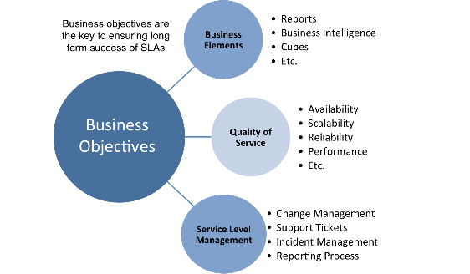To provide IT services at the lowest possible cost by agreeing with Customers their minimum requirements for service availability and ensuring performance does not exceed these targets
  2. To provide the highest possible level of service to Customers and continuously improve on this through ensuring all services operate at maximum availability
  3. To ensure that IT delivers the same standard of service at the least cost

1. The process to implement SLAs comprises of the following activities in sequence:
   1. Draft SLAs, catalogue services, review underpinning contracts and OLAs, draft SLRs, negotiate, agree SLAs
   2. Draft SLAs, review underpinning contracts and OLAs, negotiate, catalogue services,
   3. Review underpinning contracts and OLAs, draft SLAs, catalogue services, negotiate, agree SLAs
   4. Catalogue services, establish SLRs, review underpinning contracts and OLAs, negotiate service levels, agree SLAs

Reason

The sequence in option d) aligns with the logical flow of activities in setting up effective and realistic SLAs, starting from understanding what services are offered to finalizing the agreements based on those services.

1. Which of the following is an example of a service level agreement (SLA) between information systems support unit and a research unit in the laboratories of a large company?
   1. The maximum response time to get the system operational should it fail.
   2. The minimum ‘up-time’.
   3. The types of information that will be provided as standard.
   4. All of the above.

Reason

In summary, an SLA in this context would ideally encompass all these aspects to ensure that the information systems support unit meets the specific needs and expectations of the research unit.

1. Some organisations bring a degree of formality to the internal customer concept by encouraging (or requiring) different parts of the operation to agree on:
   1. Internal service agreements
   2. Service level agreements

Reason

SLAs are typically used to set clear expectations and standards for service delivery, making them a suitable tool for formalizing the internal customer concept within organizations. Therefore, the correct answer is b) Service Level Agreements.

* 1. Formal provision agreements
  2. Delivery agreements

## Index

B

bookstore 1

C

categories 6

closed-ended 7

D

data collection 9

L

Linux server 2

N

network 1

O

open-ended 7

S

Service Level 9

service level agreement 10

service quality 10

soft skills 5

support 3

T

technology 2

telecommunications 3